Money Management
O Syllabus

Teacher: Samantha Humphrey – Cell: (406)431-0044 School #:(406)324-2246 Please text or call cell number if you need a quick response.
Email: hhshumphrey@gmail.com
Website: hhshumphrey.com
Info You Need to Know:

1. Work is assigned daily, and all work should be completed/submitted by the due date.
2. “Homework” will not be assigned in addition to classwork, but students are expected to complete missing assignments, make up and test preparation as homework.
3. All due dates will be noted on the class website in the Lesson Plan Calendar; in your OneNote Classroom Notebook; and in PowerSchool.
-Late work is strongly discouraged as employers are rarely tolerant of late submissions of work. Therefore, unless otherwise identified by specific individual accommodation, all work will be docked 1 point for every day late. No late work will be accepted after the unit test.
4. This class uses online tools throughout. Primary tools in this class are Teams, the class website – hhshumphrey.com and OneNote Classroom Notebook, Knowledge Matters; Everfi and Mimic. Links are located on the Links Page in your notebook, on the unit page of the class website and on Teams.
5. You are expected to complete your own work and to cite the source when using the work of others. Penalties for plagiarism or cheating can be found in the Student Handbook.
6. Teams Meetings: Students who are in a quarantine or are not able to attend in person can participate in class via Teams. However, I must be notified if the student plans to attend so I can create a Team meeting.
a. Teams meetings will be cancelled if students miss the requested Teams meeting.

Grading:
- Tests will be worth 100 points. In the event of an absence, students must make up the test in accordance with school policy. The review will be made available but missing the review does not postpone the assessment. Students who achieve less than a 75% on any test may correct the test for half credit per correction to improve their score and demonstrate learning.

- Projects-projects may be individual or group work. Projects are valued at 100 points. A rubric and detailed description of the expectations will be provided. In groups, students will submit a group member score for each member that will be incorporated into the final grade.

- Online Simulations: Simulations such as Knowledge Matters, Everfi or Mimic, and others are all scored on a 100 point scale. Activities such as “How the Market Works” are based on participation and points may vary depending on the activity.

- Notebook/classwork assignments – Most assignments are contained within the notebook and include vocabulary words, calculation pages, forms, web quests, reading assignments and more. Points will be based on the number of items in the assessment and the amount of work each assignment requires. Students who are absent during completion of the assignment must complete the assignment in accordance with district policy. However, late work will be docked 1 point for each day the assignment is overdue.

- Professional Dress-Every Wednesday, students may earn up to 5 extra credit points for dressing in a professional manner. More details can be found on the class website under “Professional Dress.”

- PowerSchool: While I attend to get grades in right away, grades will be posted to PowerSchool by Tuesday of the following week, at the very latest. Missing work will be noted as missing and a zero awarded.

- Grading Scale: Our grading scale is as follows:

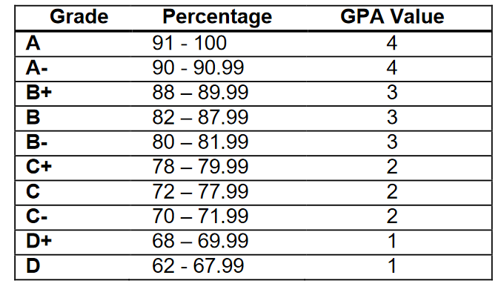 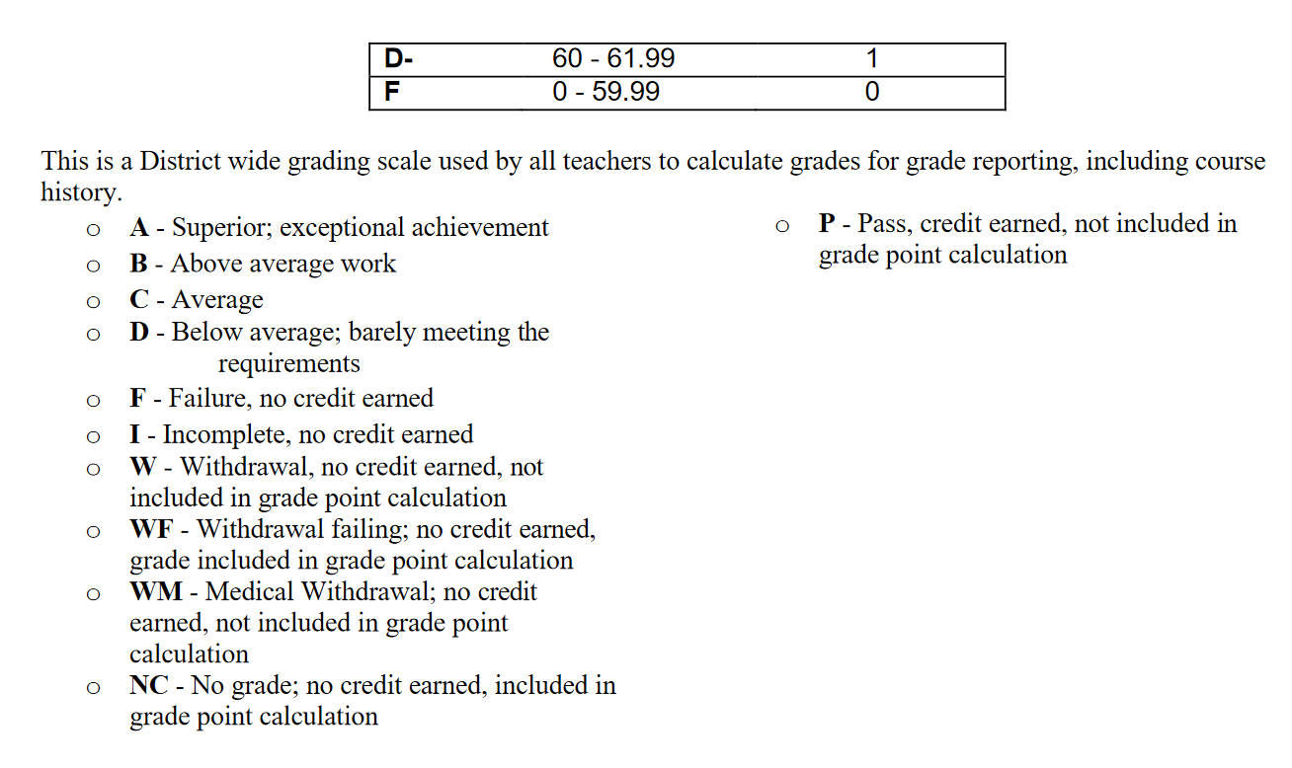-

Phone Policy:
- School is a learning environment and provides preparation for college and careers. Phones provide distractions that take away from learning. Most employers report the biggest problem with young adults is failure to work without personal phone distractions. To prepare students for college and careers and to ensure they have maximum learning in my class, all students will be expected to follow the school policy regarding cell phones and listening devices. This policy states that phones and personal listening devices will be turned off or put away during class time, unless they are being used to support a lesson.

Students who fail to follow school policy, will be assigned a Yondr pouch to use during class time.

Any violation of the policy, regardless of who the student is texting/snapping/etc. will result in the student and phone being sent to the office per district policy.

- Students who need to contact a parent or answer a phone call, should simply check with me before proceeding with the text, snapchat or call.

Masks:
Students are expected to follow the mask policy mandated by our school board. Failure to follow those mandates will result in a referral to an administrator.

BENGAL EXPECTATIONS:
Our classroom rule is to Respect people, material objects and the learning environment. As an MBI school, Students are expected to Be Respectful, Be Responsible, Be Involved, and Be a Graduate. Examples include
Be Respectful
- Respect the opinions and rights of others
- Follow directions & rules
- Keep cell phone in pocket, backpack but out of your hands
- Dress appropriately
- Speak and act appropriately
- Follow Acceptable Use Policy for computer usage
- Value yourself and others
Be Responsible
- Be on time
- Come prepared
- Complete work as assigned or make up work right away
- Ask for support when needed
- Clean up after yourself, throw away trash and tuck in chair at the end of the class
- Log off the computer
- Upon entering classroom, log on to the computer; check your email and the lesson plan calendar; web page and then begin to work on bell ringer activity
- Keep commitments
Be Involved
- Participate in group work
- Share your ideas
Be a Graduate
- Limit your absences
- Complete your work
- Set your sites on graduation and work toward it
- Realize that setbacks or obstacles are normal and work to overcome them
- Let nothing and no-one stand (including yourself) in the way of graduating on time

Unit Overview:
Activities and time frames may vary from those listed here.

Unit 1 – Introduction:
Approximate Time frame: 1.5 Weeks
Objectives:
At the conclusion of this unit, students will:
- Demonstrate or describe basic safety procedures
- Fire
- Earthquake
- Active Shooter/Intruder
- Evacuation route and location on practice field as well as location as off campus shelter
- Phone usage during emergencies
- Follow classroom procedures and rules including
- Logging on; using computers; saving documents and logging off; Windows 10
- District policy regarding computers and computer labs
- Classroom and district phone policy, food/drink policy; bathroom/water/leave policy; plagiarism and use of printers; Recycling; Dress code; Seating Assignment
- Accessing and utilizing class webpage
- Emailing or sharing assignments – determining preferred school email
  - Ensure students can:
    - Compose, read, send, reply, and forward messages to an individual or group
    - Demonstrate the ability to create an address book for individuals and groups
    - Compose and send e-mail messages using an address book
    - Attach files to an e-mail message
    - Create folders for storing and organizing e-mail messages
    - Sort, retrieve, and delete messages
    - Use proper e-mail etiquette
    - Use snipping tool
    - Use desktop/full versions of software

- Late or make up assignments
- Behavioral Expectations – including group work
- Guiding rule - RESPECT
- Have a better understanding of their classmates and me
- Know basic content coved in the class
- Be aware of how YE dollars work
- When Professional Dress day is each week and how points are earned.
- Understanding Office 365
- Using OneNote Notebook

Activities and Assessments:
- Follow business email protocol
- Introduce self to others
- Sign up for Remind
- Syllabus and class expectations and procedures quiz
- Knowledge Matters – Time Management

Unit 2: Passive Income - Investing
Approximate Time frame: 3 Weeks
Objectives:
At the conclusion of this unit, students will:
- Define Passive Income
- Describe the value of multiple streams of income and identify different streams/types of income
- Understand the value of investing as passive income
- Accurately use investment related terms
- Explain how to invest in the stock market
- Identify the types of stock brokers and reasons to use them
- Describe the relationship between risk and return
- Explain various types of bonds and reasons to invest in bonds
- Explain elements of Mutual funds, why they are an attractive investment strategy and how to invest in them.
Activities and Assessments:
- Participation in Passive Income Game Reflection Essay
- Mutual Fund Reading Quiz
- Knowledge Matters – Intro to Investing
- Knowledge Matters – Risk versus Return
- Unit Test

Unit 3: Savings:
Approximate Timeline: 3 weeks
Objectives:
At the conclusion of this unit, students will:

- Understand market conditions and determine appropriate investment strategies.
- Describe IRA accounts, mutual funds, money markets and CDs.
- Calculate various future value scenarios using time and interest rates as variable
- Identify recommended amounts and uses of different types of savings: Emergency, Short Term, Long Term and Retirement
- Describe the importance of and implement a minimum of 10% savings from each paycheck.
- Define types of savings accounts including retirement accounts, as well as terms related to savings and retirement, including IRA accounts, 401K, mutual funds, money markets CDs, Savings Bonds and Employer Match.
- Describe the Rule of 72 and the 4% Rule and perform calculations based on these rules.

Activities and Assessments:
- Understanding Social Security Reading Assessment
- 4% Rule Calculation
- Retirement Tools (Vocabulary for Retirement Instruments)
- Savings Vocabulary
- Savings Bond Reading Worksheet -
- Future Values Calculations
- Rule of 72 Calculations
- Knowledge Matters – Investing for Retirement
- Dave Ramsey – Savings
- Unit Test

End of 1st Quarter

Unit 4: Planning your Spending
Approximate Timeline: 2 weeks
Objectives:
At the conclusion of this unit, students will:
- Understand the value of a spending plan
- Know the recommended percentages associated with spending categories
- Create a budget given various income scenarios, using recommended spending percentages.
- Calculate and allocate funds for Emergency Savings; Long term Savings and Periodic Expense Savings
- Calculate necessary income to cover specific expenses.
Assessments and Activities:
- Payback Challenge Game Reflection
- Budget/Spending Plan Vocabulary
- Spending Plan Creation
- Spending Plan Percentage Calculations
- Knowledge Matters Simulation; Dave Ramsey – Budgeting Chapter 3
- Spending Plan Assessment

Unit 5: Keeping track of your money – Banking
Approximate Timeline: 1.5 Weeks
Objectives:
At the conclusion of this unit, students will:
- Manage a check book and checking related activities
- Compare and contrast Banks and Credit Unions
- Identify ways banks make billions of dollars each year
- Correctly write a check, endorse and check and make mobile deposits
- Explain the benefits and drawbacks of debit cards, direct deposit, & automatic bill pay
- Use an ATM
- Order checks
- Identify forms and uses of contactless payments and cash transfer tools

Activities and Assessments:
- Checkbook Balancing Activity
- Knowledge Matters Using Online Banking
- Knowledge Matters Choosing and Balancing a Checking Account
- Post Test
Unit 6: Identity Theft
Approximate Timeline: 1.5 Weeks
Objectives:
At the conclusion of this unit, students will:
- Identify the various methods of identity theft
- Identify methods to protect oneself from theft
- Describe the financial, emotional, psychological and time expense related to identity theft
- Locate the agencies that can help with identity theft
- Delineate the steps to take in the event of identity theft
Activities and Assessments:
- Group Research & presentation activity
- Everfi Activity
Unit 7: Credit
Approximate Timeline: 1.5 Weeks
Objectives:
At the conclusion of this unit, students will:
- Identify the lure of credit cards and the tactics of credit card companies
- Calculate the costs of credit
- Explain how to obtain a credit report and how to report errors or discrepancies
- Identify the three major credit reporting agencies
- Describe the importance of a good credit rating; the range of credit ratings and how to understand, obtain and keep a good credit rating as well as how to repair bad credit
- Discuss the relationship between credit and wealth building
Activities and Assessments:
- Minimum Payment/Payoff Worksheet
- Extra Payment/Payoff Worksheet
- Credit Related Vocabulary
- Snowball Debt Worksheet
- Dave Ramsey – Snowball Debt Reduction
- Unit Assessment
End of 2nd Quarter

Unit 8- Planning for the Future
Approximate Time frame: 4 Weeks
Objectives:
At the conclusion of this unit, students will:
- Analyze money savings methods to pay for college to include grants, scholarships; military and employment benefits and personal savings and investing
- Be familiar with college application procedures at colleges they are personally considering
- Acknowledge the difference annual attendance costs at various colleges in the Montana University System
- Determine costs associated with room and board and tuition; dorm and independent living requirements; other fees
- Detail the requirements and complete steps involved for completing the FAFSA
- Differentiate forms of financial aid and responsibilities associated with student loans
- Identify high demand/high paying jobs projected for the next 20 years using Labor Statistics
- Demonstrate knowledge about the Montana Apprenticeship Programs; how it works and programs available
- Understand how the military provides education benefits, as well as specific job training
- Research a career interest; post-secondary training requirements and locations; estimated growth and income opportunities
- Discuss the benefits and drawbacks of federal and private student loans

Activities and Assessments:
- FAFSA Reading Worksheet
- FAFSA Simulation
- Scholarship Research Activity
- Knowledge Matters Education and Advancement Simulation
- College and Career Vocabulary
- Career Research

End of 3rd Quarter

Unit 9: Income and Tax Unit
Approximate Time frame: 4 Weeks
Objectives:
At the conclusion of this unit, students will:
a. Describe the difference between typical policies and pay structures for different types of employees
b. Explain the value of employee benefits;
c. Calculate hourly pay; overtime hours & pay; gross and net pay;
d. Determine outcomes for various withholding scenarios;
e. Understand and complete various forms required for employment and for filing taxes.
e. Experience filing federal and state taxes.

Activities & Assessments:
- Worksheets: Planet Paycheck, Reading Your Pay Stub;
- W-4 and I-9 Completion
- Paycheck Calculations
- State and Federal tax filing
- Knowledge Matters Simulations
- Everfi simulations
- Income and Tax posttest.

Unit 10: Finding a place to live
Approximate Time frame: 2 Weeks
Objectives:
At the conclusion of this unit, students will:
a. Explain the difference between renting and home ownership;
b. Calculate typical costs associated with renting;
c. List ways to improve the return of a security deposit
d. Identify roles of realtors, property appraisers, banks or credit unions, and title insurers in the home ownership process
e. Calculate maximum lodging expenses versus income
f. Calculate costs associated with utilities installation and monthly costs
g. List methods to conserve money and enhance the value of a home
h. Calculate annual maintenance costs of a home
i. Understand techniques for hassle free roommates
Activities & Assessments:
- Roommate Contract;
- Mortgage Worksheet;
- Knowledge Matters Simulation
- Vocabulary Terms;
- Post Test

Unit 11: Insurance
Approximate Time frame: 2 Weeks
Objectives:
At the conclusion of this unit, students will:
a. Identify various types of coverage of vehicle insurance; requirements, minimum coverage
b. Determine needed automobile coverage
c. Explain element of risk and risk management
d. Describe homeowners insurance and types of coverage
e. Know the importance and costs associated with renters’ insurance
f. Compare and contrast various health insurance options
g. Calculate costs associated with health care
h. Explain consumer protection laws
Activities & Assessments:
- Worksheets: Liability Limits
- Identifying Financial risk
- Renter’s & Home Owner’s Insurance
- Knowledge Matters Simulations
- Post Test

Unit 14: Getting Around
Approximate Time frame: 2 Weeks
Objectives:
At the conclusion of this unit, students will:
a. Understand automobile needs at each stage of life an
b. Negotiating the best buy for the money
c. Describe methods of locating and purchasing a vehicle
d. Explain typical sales tactics and methods of negotiating a purchase
d. Understand financing options and GAP
e. Calculate mileage and fuel costs in trip planning
f. Routine maintenance; enhancing trade in value and keeping the vehicle safe and running
g. Using tools like Kelly Blue Book

Activities & Assessments:
- Trip Planning Worksheet
- Knowledge Matter Simulations
- Post Test

End of Year Project

Other Assignments:
1. Office 365 Class Notebook will contain notes and all assignments for all units.
2. Daily Mimic Simulations activities
3. Two specific literacy project based on books read in class.
4. Professional Dress Points – Extra Credit

CONTENT STANDARDS:
Standards have recently been updated. Please contact me for specific standards that are being taught.

