Steps to creating a Cover Letter
1. Get the employer’s name (manager or person hiring); name of the business and the complete business address.
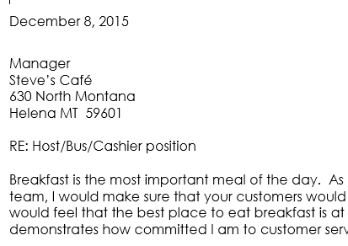
2. Open up the SAME letterhead you used for your resume.
3. Double space from the bottom of your letterhead and type the full date.
4. Double space and type the inside address (the full address of who or what business you are sending your resume and cover letter to.
5. Begin the letter with a hook to get the person interested in reading further.
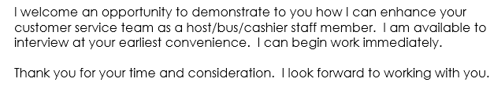
6. Briefly talk about what you would do for the company USING THE KEYWORDS FROM THE JOB ANNOUNCEMENT if hired (SELL IT!). You are basically just very briefly summarizing or reiterating some of the information in your resume.
7. Ask for the sale meaning ask if you can meet to discuss how you can be of service to the company or say you will follow up in so many days to see if they have decided who they will be interviewing. (Then be sure to actually follow up so put it in your calendar).
8. In a new paragraph or at the end, depending on how it looks and flows, thank the person for their time.
9. Close with Sincerely, or Sincerely yours. Enter 4 returns – type you name so you have a place to sign it.
10. Mail it with your resume in a number 10 envelope folding the pages together in thirds.

